Hong Kong Baptist University
College of International Education
Degree Programme

MSCN3045 Media and Integrated Marketing Communication

IMC Proposal

Group All Men

Group member list :

Wong Kwan Chin 19661118
Cheng Ka Chun 19661487
Wong Ming Choi 19661150
Li Jin Tang 19661258

Chan Pui Nam 19660987

Hung Chi Him Leo 19661029

Summary

Birdie as a telecommunication company creates unique "No contract" service for its users which allows users to join plan freely with no fixed contract and users can make every decision on their own by using the online system.

The disadvantage of Birdie's current promotional methods is that birdie doesn’t have any offline stores and platforms which may make consumers who don’t always use the internet have fewer ways to learn of Birdie.

As a result, the campaign in our proposal will focus on offline publicity in schools because schools gather a lot of target consumers of Birdie. The full campaign we aim to let the target audience enjoy the new way using telecommunication service.

Objective

1.Develop brand awareness

With the development of technology and social networks, Birdie can try to do active social media marketing on different social media platforms. Besides, multimedia is another effective way to get public awareness of the brand. For example, video, presentations and more. YouTube videos also is a way to create buzz around the brand. Create new content regularly to improve your SEO and increase your chances of being found online. The more optimized content you produce, the more likely your best buyers will find it during the buying process. Blogging is the easiest way to create consistent content. On the other hand, the quality of the content posted on social media is also important of Birdie. Therefore, the more valuable content that posted which can get higher the chance of a follower sharing their content. In addition, the Birdie can also create useful anxiety to spread the word about timely sales and limited offer to attract general public awareness.

2.Increase category demand

Students need a plan to meet the needs, the most important things are cheap and reliable, the Company could promote the plan in the school area, trying to make the investigation to understand what student really wants. It is necessary for the company to send the stuff to illustrate the difference between Birdie’s plan and other telecommunication company’s plans. Main points including; no contract, owl time unlimited data and a game could earn data. After the investigation result, customers delivery feedback and issues. A new join plan which provides the discount could encourage potential customers to join Birdie’s plan.

3. Change customer beliefs or attitude

The birdie wants the user and customer to believe that their service is better compared to other telecommunication provider. Birdie want the target audience to enjoy using their service, with contract and user can do everything online, the user just needs a device that can connect to the internet and pay the fee online. They can do every decision on their own. This is the difference between the contract service and the “No contract” online service.

4.Enhance purchase action

Unlike others, no contract and No admin fee is one of the characteristics of Birdie plan. People can choose their favourite as they want and they can change the plan at any time without the restriction of a contract. So, most users would be attracted and become a loyal user of Birdie telecommunication. For having a better service, they would experience different kinds of birdie mobile plan service so that the bridie company can earn the profits.

5. Encourage repeat purchases

Birdie provides Birdie Stamp to users. Birdie Stamp requires users to repeat purchases and get a specific number of stamps so that they can get rewards. Birdie Stamp can encourage customers to repeat purchase and increase customer loyalty. Instead of choosing another company, customers will repeat using the Birdie’s service and saving a lot of stamps to get different rewards such as 1GB extra data.

6.Build customer service

Birdie provide the best customer service. In the bride's online, we set the FAQ blank for the customers to directly solve some basic questions, such as how to assign the bride account. If customers have a question that can not find online, they can contact birdie online customer’s service through various communication, such as email, cellphone, Facebook and so on. Through that communication, our employee can answer the customers’ questions patiently and have the best mobile service to the customers. With the above methods, we build a strong link between customers and birdie.

7.Enhance firm image

Birdie aims to attract more students and the young generation to join in. As a result, the image of this firm should be vibrant, intimate and funny. Students and young generation always like new things and hope the products close to them and listen to their voice. If this company look very steady and powerful, it may help this company looked reliable but it will also make this company looked old. However, it doesn’t mean we don’t need to make our target consumers feel Birdie is a reliable company because our services are quite new and different from other telecommunication company. Therefore, new consumers may feel confused. Otherwise, Birdie needs to highlight its free image because a few limits of its products is one of the most important characteristics of Bridie’s service. Also, freedom is a very attractive word for students and young generation. In conclusion, the image we want to enhance should be young, intimate, reliable and free.

8.Reinforce purchase decision

The Birdie that can give the consumer more than their expected. It also can provide belief-raising, doubt-reducing information. Assure them they have gotten quality items at a reasonable price. Besides, it also can reinforce in their advertisement. The more creative advertisement which can get more people's attention and interest.

Target Audience

Our target audience of the birdie media plan, the students and young working teenagers as the target audience. The plan is mainly designed for the student who is between 18 to 25 years old. The target consumers do not have enough budget to pay the mobile phone charge. The consumers may not want to be limited by the contract. Nowadays, many telecommunication companies in Hong Kong require consumers to sign a contract that will last at least one or two years. But some of the consumers may not from local, the foreign students might only stay in Hong Kong for an exchange plan or a business trip. Usually, this kind of plan will last for half-year. Obviously, the telecommunication ‘s contract period is too long for them, space card might be an option, but it will be costly, the birdie plan provide low lost plan for students. Birdie ‘s plan has no contract; the consumer could cancel the plan at any time. The relatively cheap price is suitable for the students.

A memorable campaign on how to promote Birdie student plan in/around campus

We plan to make a short term carnival inside campus. This carnival will last three days to make sure more students can gain chances to access. This carnival will be held on the school’s open areas like dining hall or school club publicity area. We need to make sure this area will be a common gathering place for students and it won’t occupy students’ study areas. In each day, the carnival will last around three hours during 11:30 to 14:30. In this carnival, students can gain special award in Birdie’s game in Birdie Farm which will help them gain more data in this game or help fresh players can access this game faster. The reason why we plan to make this carnival focuses on this game is we believe students will be more interested in playing game than listening of direct explanation of telecommunication company and plan. In order to make sure all participator can get access to this game; we will make free high-speed Wi-Fi in the locale of this carnival. Surely, other people who don’t want to play this game also can use this Wi-Fi. We can make an introduction website for Birdie. If any people want to use this WIFI, they will access this website first. Therefore, this Wi-Fi will also help advertise Birdie. In addition, we can paint special icons of Birdie in school. For example, on the surface of the recycling bin, some chairs in the public room to enhance the efficiency of publicity. This activity can last longer than the carnival. We think two weeks is a suitable time. In conclusion, this carnival will help people who are interested in mobile game learn more about birdie. Also, people who want to use free high-speed Wi-Fi will also gain chances to learn of Birdie and other people can recognize Birdie by seeing these special icons.
Media mix (channels) e.g. dummies, sketches, schedules
As birdie do not real shop, they usually Out Of Home Media as their main promotion channel, based on the target audience interest of students and the working teenager, the working teenagers like to use different social media as their main communication method with their friend. So we will make use of social media such as Instagram and Facebook to post the post and information of birdie and the birdie students plan. After posting the information on social media, the customer see the information, if they feel interested about the birdie service they will use also they recommend to their friends. The most important issue is to increase the popularity of birdie toward those students and young people

Promotional tools

Since now the online social media platform is the most effective platform, placing the advertisements on Facebook, Instagram and YouTube will be the good choices. Comparing with traditional tools, Facebook and Instagram breaks the age readership limitation, there are few teenagers will purchase the journals or newspaper. Internet spread the information in the most quickly way, the one who watch the short video or the posts will see the Birdie sponsored advertisements. According to statistics figure about the number of social media users in October 2019, there are 5654000 Facebook users and 2237000 Instagram users in Hong Kong. YouTube provides a large market, actually YouTube is dominating the video website, It is no doubt that YouTube has more viewers than television media. Birdie could also apply the OOH media, Hong Kong is a compact city, transportation tools occur at every corner of urban area. Bus shelter, bus body or billboard are defined tools to gain citizen's attention. Especially in places like Mong Kok, Causeway Bay.

Weekly posts based on the proposed schedule

In all IMC media plan, we post around 12 posts with different theme in three weeks. In the first week, we mainly introduce the characteristics and content of ‘Birdie’ plan. The purpose is that we would like to allow all people to know about our product and its basic background, which improve the customer’s interests in our product. In the second week, we introduce the benefit of using the birdie plan, including concert tickets, games and birdie WhatsApp sticker. Therefore, the customers can clearly understand the advantages of using a birdie plan instead of others and would be attracted by the new plan, having more opportunity to become the potential fidelity customers. In the third week, we mainly talk about what is ‘DATA’ and how to use or add ‘DATA’. Mainly, we think that ‘DATA’ is one of the most significant things that people are concerned. More data telecommunication provide, More people choose the plan. Capturing with the situation, we introduce people how to get more data for free and what gift they can earn. In short, more people would choose the birdie as their mobile internet. In the fourth week, we introduce some discounts that people would interest, such as free data at midnight, cheap data during a foreign trip and e-pay. Different posts target on different people’s need. Some people prefer using e-pay rather than cash; others prefer to travel around the world and can use the internet freely. For those special need’s customers, they would also be attracted to attend the birdie plan, which increases the number of potential customers and sales.

Posts
week | Topic | Topic | Topic
1 | 用咩plan 你有say!  Let the customer to understand different service plan of the birdie | 恒生Green Banking 大專信用卡比你「攞盡著數」using the students plan to gain jets, such as travelling data in 12 Asia countries. | 叫朋友join自由鳥有更多數據比你用！share the plan with your friends which can gain more data!
2 | 星期五Fun Fun 搶，戲飛﹑演唱會飛任你搶。  Every Friday，birdie offered the gift coupon or tickets for customers to enjoy. | 拿拿聲使用自由鳥APP同人鬥搶禮品Using birdie app to get the gift！Apple Pay pay the bill which can have a discount! | 想擁有與眾不同的whatsapp sticker ，黎用自由鳥啦  If you want the special WhatsApp sticker,come and join our plan.
3 | DATA越玩越多 你試過未！  Let customers know the characteristics of the mobile game BirdieFarm and how it can help customers gain more data. | DATA自由share 友情更加分！  Let customers know that the local data involves in their plan can share with other people freely. | 介紹朋友加入，助你成為充滿DATA的自由鳥  Invite friends to join birdie and become a full data birdie.
4 | 你係夜訓家族，咁自由烏岩哂你!  You are The Owl “Birdie” is your best choice 1-6 am you can use the data for free | 去旅游，玩到儘，唔使換sim卡，自由鳥app一鍵落單買漫游，價格親民，自由鳥陪你瘋玩假期。  Customers do not need to change SIM card while they using Birdie service, and roaming charges price is relative cheap., | 用ePay交錢有更多優惠！use ePay pay the bill which can have a discount!
- 用咩plan 你有say!
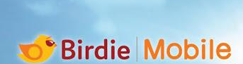
What is our Birdie Plan? How can we tell the differences?
For attracting more birdie friends, we introduce different mobile media plan. Different with other mobile telecommunication, one of the characteristics of birdie is no contract and no intermediate fee. Basically with 4 different services (12GB,7GB,5GB and 500MB). Each different plan with different service and price. And we are plausible to talk to others that our plan is the humanize plan. If you want to learn more, please check the following link.

#Mobile App #Best Mobile Pay App #Mobile Plan
Shared Link: https://www.birdie.com.hk/mobile/mobile-app-features/?lang=zh
This post plan to provide the basic background of the birdie plan, which attract more people to get familiar with the birdie company.

- 恒生Green Banking 大專信用卡比你「攞盡著數」using the students plan to gain jets, such as travelling data in 12 Asia countries.
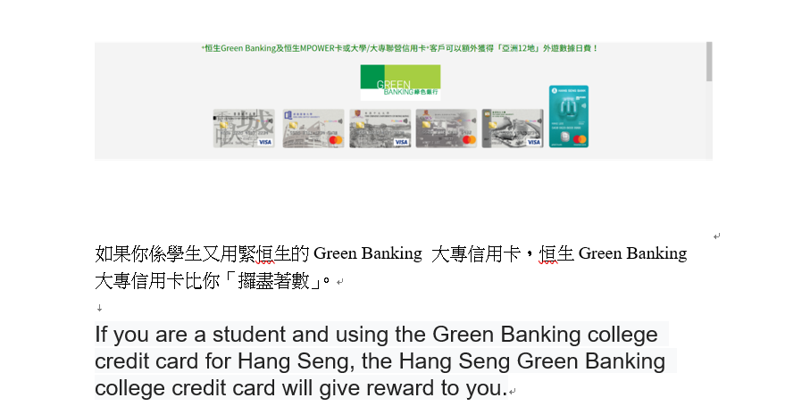

- 叫朋友join自由鳥有更多數據比你用！share the plan with your friends which can gain more data!
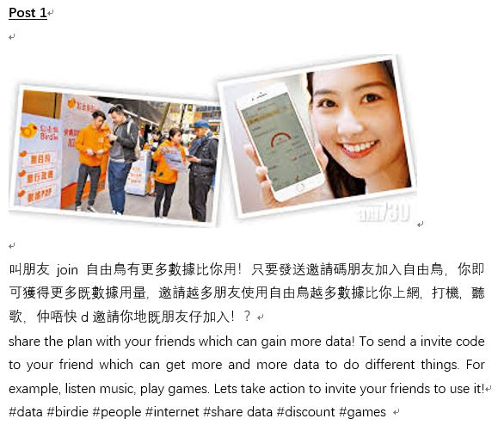

The aim of this post wants to use social relationships to promote the Birdie plans to their friends which can increase the attention of the company and provide benefits to the customers.

- 叫朋友join自由鳥有更多數據比你用！

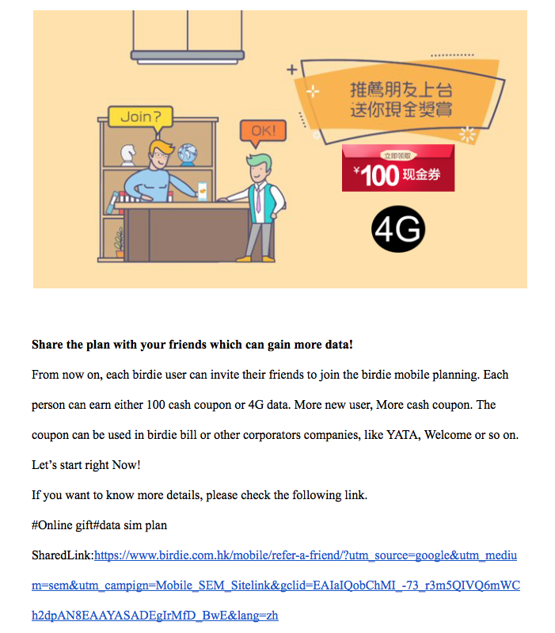
In this post, we want to introduce how to get more data by adding more friends. Also, the customers can share the happiness with their friends by using the birdie, which increase the customer’s fidelity and the number of potential customers.

- Enjoy Birdie Friday with friends
After a week of busy want to comfort self and relax “Birdie Friday” is a campaign that every Friday Birdie offers the gift coupon or concert tickets to customer to enjoy and keep using “Birdie service”. this campaign is “First come, first served, while stock lasts”. What are you waiting for? Join “Birdie Friday"!!! Enjoy happy Friday with your friend.# Birdie Friday
# First come First served #gifts # ticket # drink # offers #fast

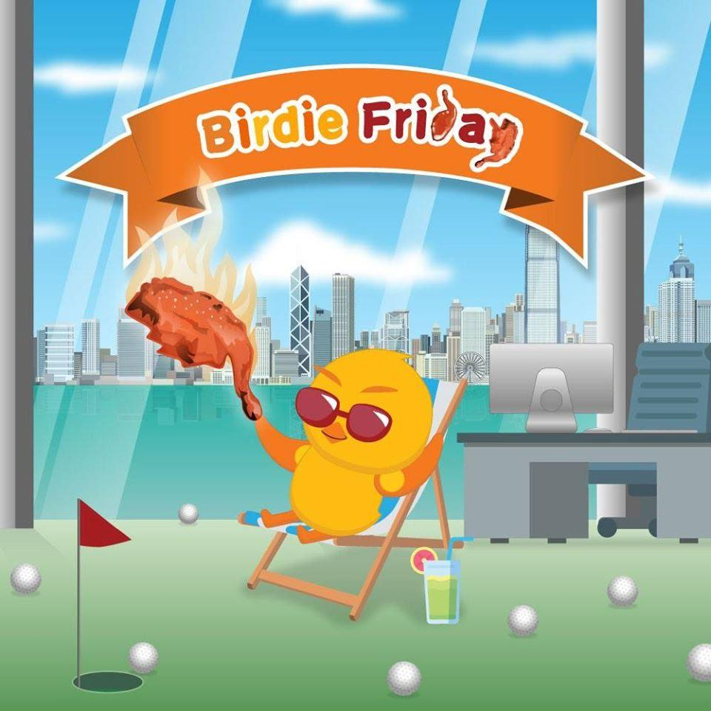

- 拿拿聲使用自由鳥APP同人鬥搶禮品Using birdie app to get the gift！Apple Pay pay the bill which can have a discount!
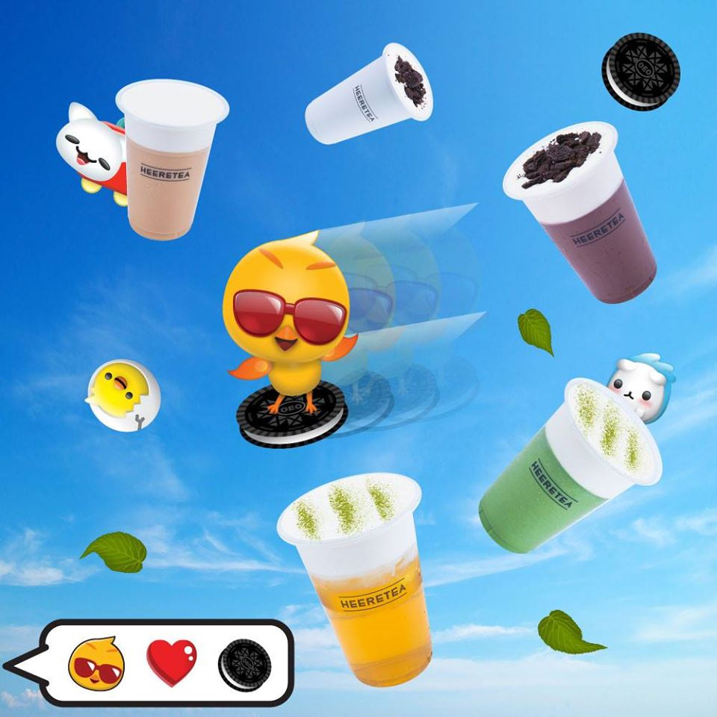
下載自由鳥APP，每週領取限量免費禮券！奶茶，雪糕，雞髀，應有盡有！仲唔快D過來搶？
Downloading the app of Birdie, you can gain free coupon every week！It will cover all the things you want including milk tea, ice cream, drumsticks and so on! Using the app as fast as possible, you will get more!

This post aims to attract more users to download the Birdie app. Also, it will attract potential users especially young people because they will be interested in free delicious food. Also, it will make people think Birdie is a nice company which tries to give users more benefits.

- 想擁有與眾不同的WhatsApp sticker ，黎用自由鳥啦 If you want the special WhatsApp sticker, come and join our plan.

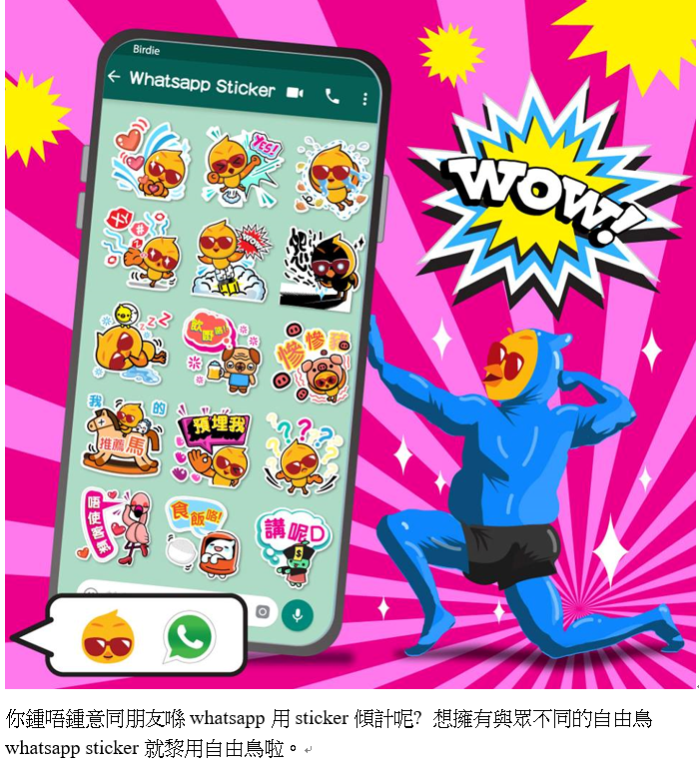

- DATA越玩越多 你試過未！
Let customers know the characteristics of the mobile game Birdie Farm and how it can help customers gain more data.

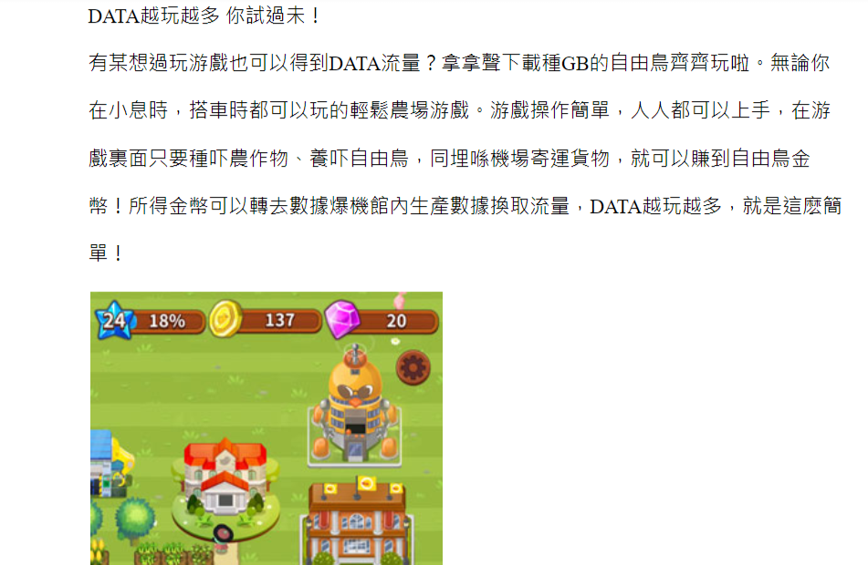
This post will face to the one who like to play the farm game, It’s easy to play.Most important thing is that you can win the data.

- DATA自由share 友情更加分！Sharing your data freely, your friendship will become tighter!
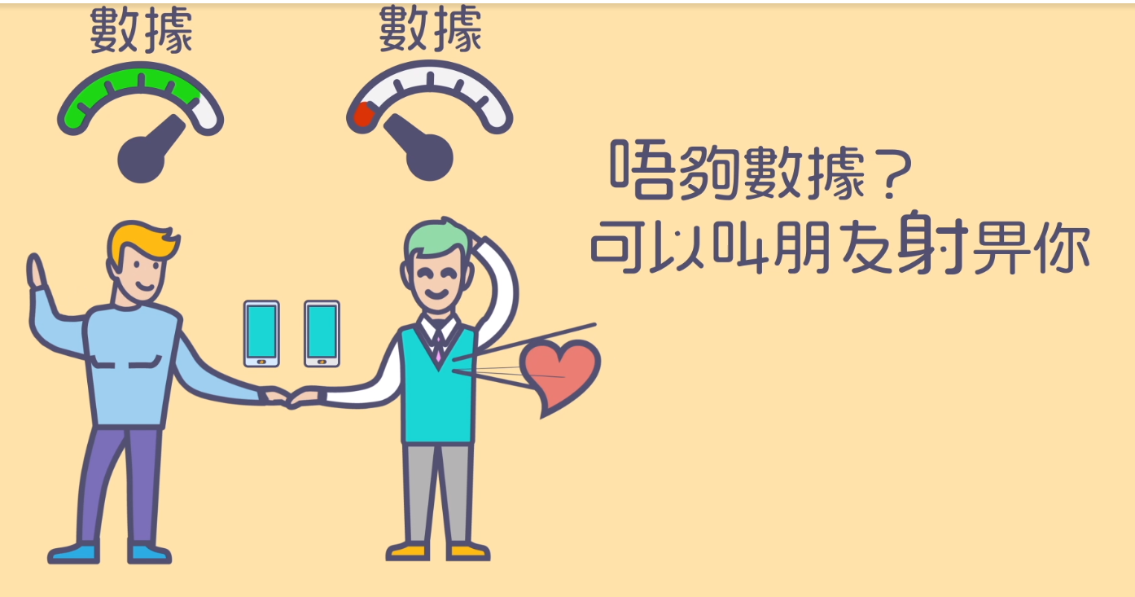
每月流量仲有剩？唔使驚！加入自由鳥，每月流量可自由分享給其他用戶。唔單止流量唔會浪費，仲可以幫助和朋友建立更深厚的友誼！
If you still have a lot of data unused this week? Don’t be afraid! If you join in Birdie, you can share your data with other users freely! It not only helps you keep the value of your data but also makes the friendship between you and your friends become tighter!

This post will attract people who don’t use all the data each month. If they know join in Birdie can share their remaining data, they will join plan with less hesitation because the data won’t be wasted.

- 你係夜訓家族，咁自由烏岩哂你!
You are The Owl “Birdie” is your best choice 1-6 am you can use the data for free

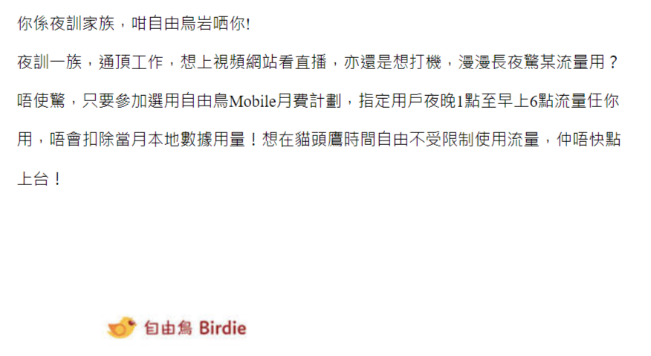
The purpose of this post aim to attract the owl time users, during 1am to 6am, the one who join the certain Birdie plan could enjoy the unlimited data. The night users will benefit from it.

- Enjoy using the most famous travelling sim card.
Do you like going to travel? You need a travelling sim card, Birdie travelling sim card will be your best choice for you to enjoy the trip with low cost, it is so cheap as a result you can save more money for your travel. You can enjoy $15 per day in 11 Asia countries.
# travel sim card #low cost # trip # Enjoy travel #saving money
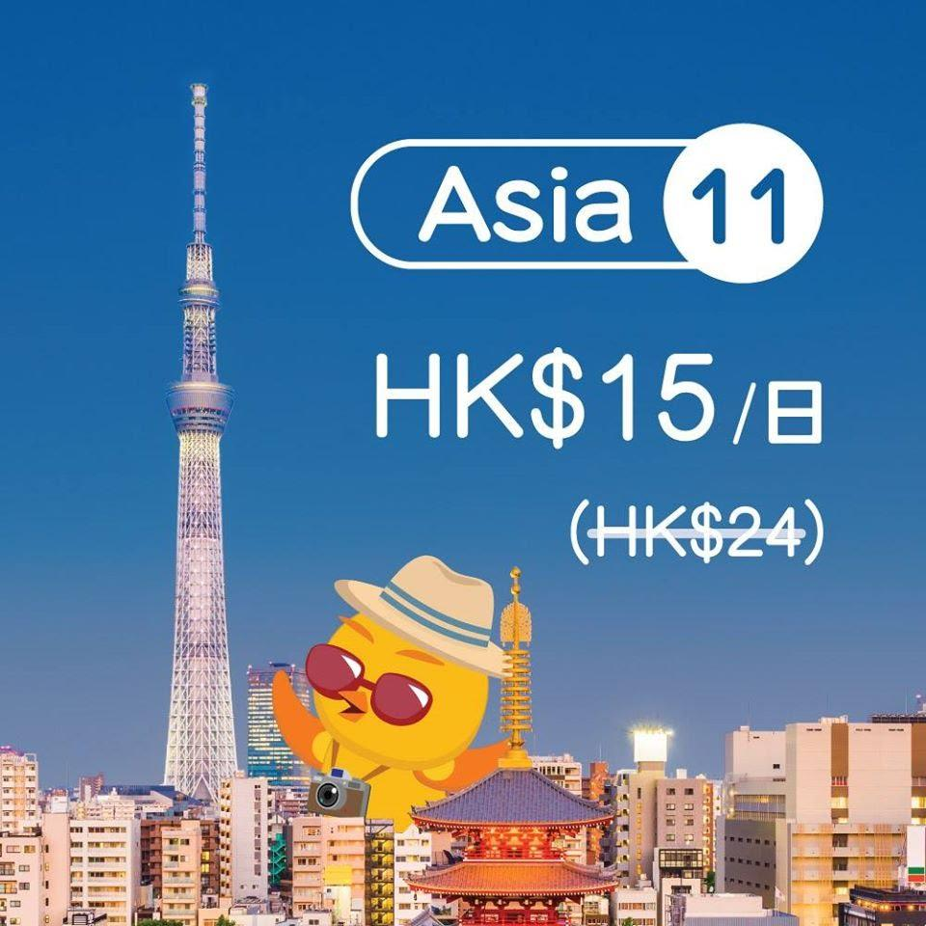

- 用ePay交錢有更多優惠！use ePay pay the bill which can have a discount!

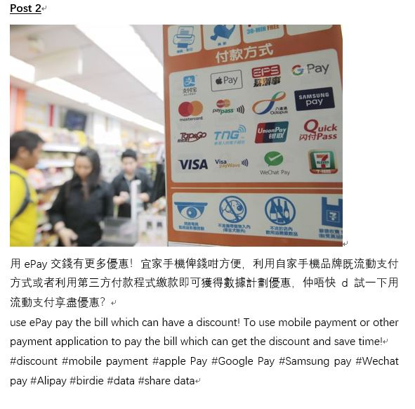
The aim of the post wants to share another payment method to other people and encourage them to use E-Payment to pay the bill. On the other hand, it wants to increase the sales.

The expect coverage
Basically, we want to post our posts on different social media platforms, including Facebook and Instagram.

Creative theme & style
With the original goal of our theme “Free Flying”, we want to create a relaxing and comforting atmosphere to the customers. Also, our campaign focus on full and joy elements so that the customers are very pleasant and have positive influences on the birdie’s brand image.

The expected results

The first expected results of our IMC plan is improving the product exposure among our target audience, especially students and young teenagers because Birdie is not an old brand, not too many people know Birdie. Secondly, making them understand the differences between Birdie and other telecommunication company in Hong Kong. The service Birdie provides is very different from other telecommunication company in Hong Kong and these characteristics should be attractive for students and young generation. If this campaign can help our target consumers make sense of these characteristics, we think they will be interested to join the plans Birdie provides. Thirdly, making target consumers know how to join these plans. It is also important because the simplification of the joining process is one of our important selling points. In our campaign, we won’t directly encourage our target audience to join Birdie’s plans but we believe we will achieve this purpose through this campaign and it should be our final goal and results.

Deep analysis of the proposal

In our proposal, the main idea is trying to make our target audience feel Birdie is an interesting and lively company. Because our target audience is students in university and young generation, they prefer company which fit their young image and taste. Therefore, we think a carnival should be attractive to them. In this carnival, we mainly encourage the participants play the game Birdie Farm because mobile game may fit students’ taste and it will make our target audience think Birdie is a company with young taste and feel this company is close to them. Also, offline carnival can make up the disadvantage of Birdie’s current publicity’s channel because Birdie’s current publicity’s channel just focus on online ways. In addition, we want to highlight the image of Birdie as a free company because young people like freedom. Therefore, we won’t force students to hear too many explanations about Birdie or encourage them to join plan directly to increase their pressure. Just try to make them feel free to join the game. Otherwise, we need to attract more audience to join the carnival. Hence, painting some logo of Birdie on recycling bins and chair is necessary. In order to avoid students, feel this carnival will influence their study, we plan to make all these activities outside classrooms and study areas but we also need to make sure the location should have enough people go through. Canteen should be a suitable place which fits our requirement. If we hold on canteen, we can provide some free and delicious food for students to enjoy. It will make people feel our activities more interesting. Surely, we think only offline carnival is not enough. As a result, we will also publicity Birdie in social media like Facebook and Instagram. These social media also own a lot of young users and they are also popular in our target audiences. Posting the information of this carnival may help raise public awareness about Birdie because seldom telecommunication companies hold similar carnival in school. In conclusion, the whole campaign in this proposal aim to build young, lively and free image of Birdie and we think carnival should be a creative and suitable choice.

